Welcome
Terror in the Night Halloween productions 2018

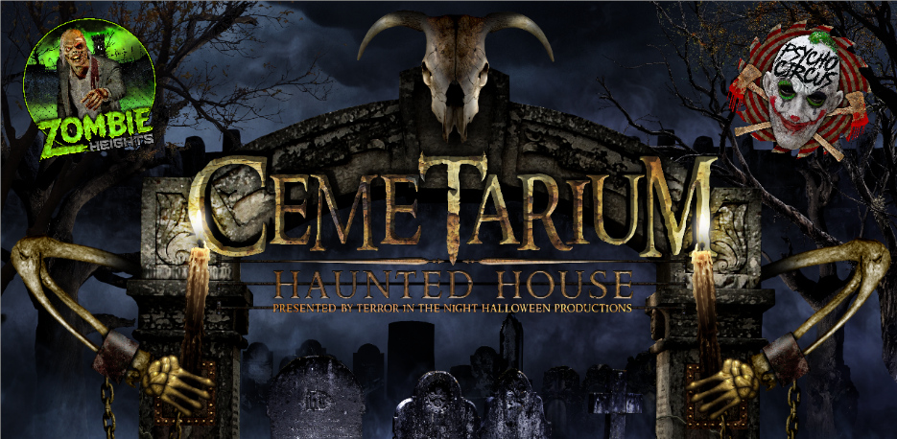
Thanks to the new and returning volunteers for choosing to participate in the 9th annual Cemetarium Haunted House!
Please read this handbook. All volunteers must be 18 years and older and sign a release of liability form. If you are between 14 and 18 years of age and want to participate we will need a signed release of liability form by you and your parent or guardian. A parent or guardian must confirm the signature. The form is located at the back of this handbook.

Terror Definitions
- Cemetarium – our haunted attraction
- Psycho Circus – our freaks & clown themed attraction
- Zombie Heights – not open this season
- Volunteer – actors, makeup, security or anyone signed up
- Fresh Meat – our customers
- House Management: Frankie Babcock, Troy Clapham, Kathy Aus and Peggy the old hag
- Actor Management: John Cortijo, Merissa Guerra and Deirdra Estes
- Terror in the Night Halloween Productions produces: Cemetarium Haunted House / Psycho Circus / Zombie Heights (Citrus Heights) - Monsters In Modesto Haunted Attraction (Modesto) - Horror in the Flesh Makeup Crew - Hauntraband.com
Contents
- Attraction Rules
- Emergency Action Plan (EAP)
- Volunteer Rules, Safety and Fun Stuff
- Release of Liability Form
(Must be signed and turned in prior to participating)
Contact:
Frankie Babcock 916-223-9080 Troy Clapham 916-532-3464
cemetariumhauntedhouse.hauntscheduler.com
Haunted House Rules

- No Alcohol!!! No Smoking!!! No Exceptions!!!
- No photography or video recording of any kind!!!
- No cell phones in hand! Cell phones must be turned off and put away while in the Attractions (they are often dropped and lost).
- For everyone’s safety, No running!
- Please do not touch the actors and they will not touch you (incidental contact may happen).
- Please do not touch any props.
- Wheelchair Accessible (inquire at the ticket booth).
- Food or drinks in the wait line only. Not in the Attractions!
- No Refunds!!!

Emergency Action Plan part 1
Fire Emergency
In the event of a fire the most important thing to remember is to stay calm. It will be your duty to keep our guests calm and escort them to the nearest emergency exit. Instruct them not to run as this may cause people to trip and fall. After the guests are safely out alert house management ASAP! At that time we will cut power to the haunt while turning on house lights and announce over loudspeaker the emergency to the entire site. Any properly trained volunteer may use a fire extinguisher if it is safe to do so.
If you are not comfortable doing this please do not attempt to!

Fire Extinguisher Operation
P.a.s.s. Pull – Aim – Squeeze – Sweep
P = pull the pin and completely remove it from the extinguisher handle
A = aim the extinguisher nozzle towards the base of the flame
S = squeeze the handle to discharge extinguisher material
S = sweep the spray from extinguisher across the base of the flame
To call in a fire or medical emergency from a cell phone in Sacramento County dial: 228-3000

Emergency Action Plan part 2

Medical Emergency

- A medical emergency needs to be assessed prior to taking action.
- Alert house management or security if you discover a medical emergency.
- House management or security shall call in the emergency.
- If the guest or volunteer appear unconscious or seriously injured do not move them!
- If the guest or volunteer appear ill, have minor injuries and are able to walk on their own they should be assisted to the nearest exit and wait for proper medical attention.
- We have fully stocked first aid kits located at:
- Ticket booth
- Make up table

To call in a fire or medical emergency from a cell phone in Sacramento County dial: 228-3000

Emergency action plan part 3

Power Outage Guidelines

- Turn on your flashlights and illuminate the area around you and our guests.
- Assure the guests that everything is ok and to remain calm.
- Alert house management or security to the power outage.
- House management will turn on house lights and announce over loudspeaker the emergency to the entire site.
- If after a thorough inspection, the problem diagnosed and corrected we will resume operating the haunt.
- If the problem is not correctable in a short amount of time we will escort our guests to the nearest exit.

This type of emergency does not require calling the Fire Dept. or emergency services.

Rules and Safety
- Attractions. Cemetarium & Zombie Heights: You must be at least 14 years of age to volunteer. Psycho Circus: You must be at least 16 years of age to volunteer.
- No smoking or open flame devices! Sacramento Metro Fire Dept. prohibits smoking in a haunted house as does Terror in the Night Halloween Productions.
- First aid kits are located at:
- Makeup dept.
- Fire extinguishers. All volunteers must know the locations of all the fire extinguishers in the haunt and how to use one as well.
- Flashlights. All volunteers will have a flashlight at their designated locations. We will check the operation of the flashlights prior to Showtime but you must check it as well. House management will hand out flashlights to everyone prior to Showtime.
- Emergency lights. In the event of a power failure or other incident the emergency lights will be turned on. At this time please escort our guests to the nearest emergency exit. Make sure to use your flashlight for safety.
- Exits. Volunteers must know the locations of all exits. We consider all exits between the entrance and the final exit to be emergency exits.
- Tour guides. Actors will be the tour guide(s) for their designated area. It will be your responsibility to keep the guests moving in the proper direction. A minimum of one actor in each designated area will have a two way radio for communication.
- ADA (Americans with Disabilities Act). Cemetarium Haunted House is an ADA friendly haunt. We are designed to make it easier for someone in a wheelchair or disability to participate in the tour. If we have a guest in a wheelchair or with a disability and they do not have someone to assist them we will have a volunteer help them through the tour. Please let us know in advance if you are not willing to perform this assistance.
- Hazards. If you see something that is a potential safety hazard (sharp object, tripping hazard, loose prop or decoration) please let house management know ASAP!
- Guests actions. If you see any guest touching, handling, stealing any props, decorations or items belonging to Terror in the Night Halloween Productions and if you see any guest that appears to be intoxicated, using loud foul language or displaying aggressive behavior toward another guest or volunteer please let house management or security know ASAP!
- Cell phones. “Cell phones must be put away at all times” while performing and have the volume turned off or to vibrate. We ask that you use your cell phones in the actor lounge area and during breaks only. Not in any of the scene areas. This will help in a more professional production for our paying fresh meat. This will be strictly enforced. Thank You!
- Working as a team. NO PERSONAL DRAMA HERE! Let’s keep it fun! There will be many volunteers working the attractions so we all need to respect each other. Please do not use bad language or exhibit inappropriate behavior while volunteering at the haunt. You could be asked to leave if you do.
- Photography: Under no circumstances are you allowed to photograph or take video inside any attraction without written permission from Frankie or Troy. This applies to everyone.
Fun Stuff!!!

1. Volunteer Registration. When you register to volunteer, you are agreeing to scare from the haunt/room we assign you. You will get to try different scares and rooms on different days but you must be willing to scare from where we need you on any day. All volunteers must register and create a personal profile at cemetariumhauntedhouse.hauntscheduler.com prior to volunteering. In your online profile you must check in and check out on the days you volunteer. You will also need to sign a “sign in sheet” on the days you volunteer. This will be used when you’re called for makeup. Makeup artists arrive between 3pm & 4pm. Actors arrive between 4pm and 6pm with 6:15pm being the cut-off time for actor arrival. We will absolutely be flexible with your school / work schedule but please communicate this with us ahead of time. We ask that if you sign in to be an actor, you are signing in to scare until we close. PLEASE STAY UNTIL CLOSING. All makeup artists that are not acting are asked to please stay until everyone has makeup. Makeup artists may stay until closing if you’d like.
2. Costumes and Make-up. Your costume and make-up will be designed to fit your scene. We ask that you wear dark colored shoes unless your scene requires another color. Your shoes need to have flat soles. No heels or sandals please! Please put costumes back on the rack where you got them. Do not leave the haunt property wearing our costumes. All outside costumes must be approved by us so please just ask. All makeup designs used will be ours. All outside makeup designs must be approved by us prior to arrival.
3. Performing your scare!!! This is why you’re here! Watching and waiting for the right moment to startle the fresh meat that just turned the corner! Sometimes in the chaos you will hear “I just peed my pants”!!!
At the same time not every scene requires you to scare them and you most likely are not going to scare everyone. The scare is important but performing your scene and interacting with the fresh meat are very important as well. So if you can’t scare someone but you interact with them you can still make it fun for them, creep them out and YOU may be the one they remember the most. So, DON’T BREAK CHARACTER!
What to do and what not to do:
- Stay in your assigned area! Do not leave it for another area.
- Do not take other actors scares!
- Do not scare from emergency exits! Scare from your assigned area!
- Do not yell at the fresh meat and tell them to “get out” as part of a scare.
- Respect all volunteers and fresh meat!
- Please pick up your trash (food, water bottles etc.).
- No chasing any fresh meat outside the attractions or in the parking lot.
During your performance, we ask that you do not touch the fresh meat just as we ask the fresh meat to not touch the actors. We know that incidental contact may happen.
4. Breaks. We will have breaks at periodic intervals according to attendance. If you need to use the restroom during the show please work that out with another actor in your area to cover your scene.
5. Restrooms. We have restrooms available in the main building.
6. Refreshments and snacks. There will be ice chests with drinks and snacks available in the main building.
7. Have fun and make new friends!!! The rules are in place so we can all have a good time. We want this to be a great experience for you and one to remember for years to come! Volunteering at Cemetarium Haunted House, Psycho Circus & Zombie Heights is a fun way to make new friends and we appreciate all the friends that we have made here over the years. We look forward to meeting you!
8. T-shirts! Everyone volunteering 5 full days will earn a t-shirt! You must make sure to fill out the sign in sheet every day when you arrive. You must also check in, check out in your actor profile at Haunt Scheduler so we know you were here and can earn a shirt. Please note that signing in then leaving before we close will not count towards a shirt. T-shirts will be available at the pizza party.
9. Hoodies & T-shirts! Everyone volunteering 15 full days will earn a hoodie and a t-shirt! You must make sure to fill out the sign in sheet every day when you arrive. You must also check in, check out in your actor profile at Haunt Scheduler so we know you were here and can earn a shirt. Please note that signing in then leaving before we close will not count towards a hoodie or shirt. Hoodies must be ordered and will be available after the pizza party. If you earned one, you will be notified when they arrive. NEW RULE FOR 2018! If you earn a t-shirt and hoodie plus "NEVER LEAVE EARLY" you will earn an additional 3 haunt shirts! You will get a Cemetarium shirt, a Psycho Circus shirt and a Zombie Heights shirt (even though it's not open this year)!
10. Pizza Party!!! To show our appreciation to our volunteers Terror in the Night Halloween Productions will have a cast pizza party on November 10th , at the haunt! It will be a great time to share stories and talk about the perfect scare!!!

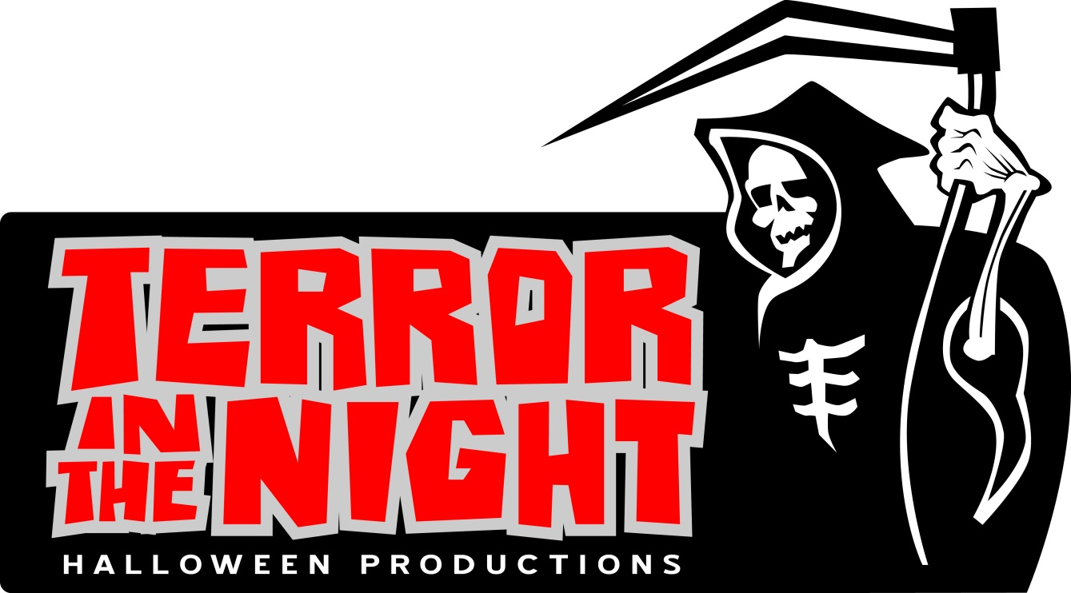

Cemetarium Haunted House Release of Liability Form

Please Print Clearly!

I (print name ) ____________________________________ acknowledge and agree to not hold Terror in the Night Halloween Productions / Sunrise Fun Center Property Owner liable for any damage or injury received or sustained as a result of my participation in a volunteer status as an actor, staff member or any capacity in this year’s Cemetarium Haunted House 2018. Any valuables are brought at my own risk.
I acknowledge that I will be working outdoors in low lighting conditions with fog machines, loud audio, uneven ground, platform surfaces and various types of hiding places constructed with various types of materials. Construction help will be using common framing tools, ladders and basic power tools at your own risk. Do not use them if you’re not comfortable doing so.
I also acknowledge to have read the Volunteer Handbook and will abide by the rules. I agree to make known to management or security any potential safety hazards found (sharp objects, tripping hazards, loose, broken prop or decoration, etc.) as soon as possible.
I agree to make known to management or security any guest seen not following our Haunted House rules and anyone seen touching, handling, stealing any props, decorations or items belonging to Terror in the Night Halloween Productions.
I agree to make known to management or security ASAP any guest that appears to be intoxicated, smoking, using loud foul language or displaying aggressive behavior to another guest or volunteer.
I agree to not use foul language or exhibit inappropriate behavior while volunteering.
I agree (as stated in the Volunteer Handbook) to use my cell phone in the actors lounge area and only on breaks. Not in the scene or scare areas and not between touring groups. This will be strictly enforced!
I agree to not take pictures or video inside any attraction for any reason without written permission from Frankie or Troy only. This applies to everyone! A picture or video outside of any haunt is fine. I agree that any pictures or video taken of me by Terror in the Night Halloween Productions may be used for haunt related advertising and promotion.
Have you ever been convicted of a crime? Yes___ No___ If yes please describe _____________________________________
Volunteers Signature ________________________________________________________Date ____________
Volunteers date of birth _________________
Parent or Guardian Signature ________________________________________________Date ______________
(Parent must sign as well for volunteer if under 18)
Email (print clearly) __________________________________________________Phone # ________________
Will you be attending the cast pizza party on November 10th? Yes_____ No _____
T-shirt size ______________ (If left blank you will not receive a t-shirt.)
T shirt type: Traditional Men’s ___________ Women’s Baby Doll __________
Hoodie size ______________ (If left blank you will not receive a hoodie)

Form must be signed, dated and turned in prior to participation. Please print clearly and fill out form completely.
Cemetarium Haunted House Release of Liability Form 2
Cemetarium PIT (No PIT This Year)

I (please print) __________________________________________I agree to not hold Terror in the Night Halloween Productions or Sunrise Fun Center property owner liable for any injury received or sustained from my voluntary participation as an actor in the Cemetarium Pit.
The Cemetarium Pit is a block wall encased hole in the ground about 4ft deep with narrow stairs. It is being used as a primary scene in the Cemetarium Bridge area themed room.
It will be dimly lit and requires you to walk up or down carefully and slowly. It can be dangerous if you run.
You are acknowledging that you understand this and are volunteering to work the Cemetarium Pit.

Please sign below to work the Cemetarium Pit!
Volunteers Signature ________________________________________________________Date ____________
Volunteers date of birth _________________
Parent or Guardian Signature ________________________________________________Date ______________
(Parent must sign as well for volunteer if under 18)

Cemetarium Haunted House Release of Liability Form 3
Overhead Platforms

I (please print) __________________________________________I agree to not hold Terror in the Night Halloween Productions or Sunrise Fun Center property owner liable for any injury received or sustained from my voluntary participation as an actor on any OVERHEAD PLATFORMS.
An Overhead Platform is any overhead area designed for actor use.
You agree to not stand on any Overhead Platform and perform only from getting low on your knees or lying flat. When working an Overhead Platform you are agreeing that you will not be climbing up and down unnecessarily and will follow our instructions for these scare areas.
You are acknowledging that you understand this and are volunteering to work Overhead Platforms.

Please sign below to work Overhead Platforms!
Volunteers Signature ________________________________________________________Date ____________
Volunteers date of birth _________________
Parent or Guardian Signature ________________________________________________Date ______________
(Parent must sign as well for volunteer if under 18)

